Background Information (click on the arrow to expand)
- Include a header (on each page) with:
  - CONFIDENTIAL
    - This will mean none of the submission will not be posted online but the committee will read it.
  - If there are parts of the submission that you want to keep private, include CONFIDENTIAL and then in your cover letter for submission you can explain what is confidential. For example “Dear Committee Secretariat, please redact the names and place names mentioned in this submission.”
    - This will mean that the main submission will be included but any identifiable information will be removed (usually this is blocked out) before it is published online.

  - Optional: Include this text: Inquiry into economic self-determination and opportunities for First Nations Australians Submission
- Optional: Include page numbers (on each page)
- Optional: Include the following on the first page/letter for the submission:
  - The date you will submit e.g. “Thursday 11 July 2024”
  - The address of the committee:
    - Committee Secretary
Senate Legal and Constitutional Affairs Committee
PO Box 6100 Parliament House Canberra ACT 2600
Phone: +61 2 6277 3560
  - Include “By email” if you are emailing it across e.g. “By email: legcon.sen@aph.gov.au”
- Then write your cover letter/introduction to the submission, using the guide below on what to include, at the end of the submission (this could be one page or multiple pages) sign off with:
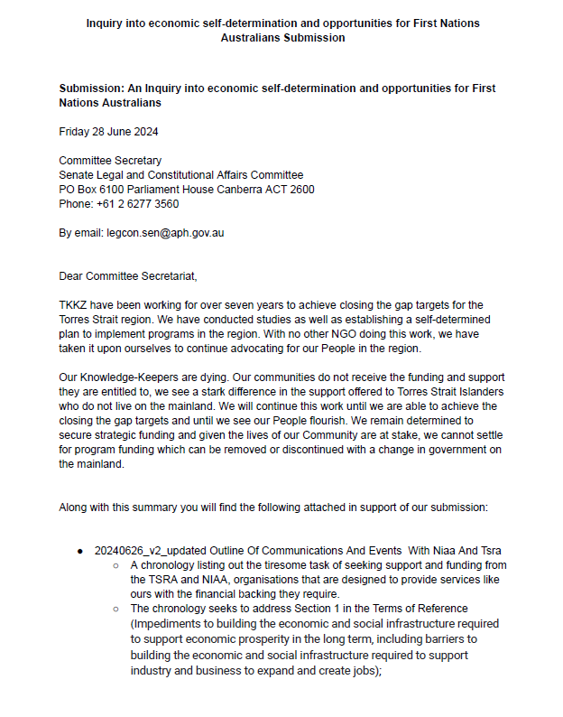
  - Your name
  - Your contact information (this will not be displayed online)

Here is an example of what a submission can look like:

If your submission is accepted it will be posted on the committee website.

To see examples of other submissions (from the now closed Senate An Inquiry into economic self-determination and opportunities for First Nations Australians). You can view them here.

Template
CONFIDENTIAL

DATE

Committee Secretary
Senate Legal and Constitutional Affairs Committee
PO Box 6100 Parliament House Canberra ACT 2600
Phone: +61 2 6277 3560

By email: legcon.sen@aph.gov.au

Dear Committee Secretariat,

- A bit about yourself
- Why you are writing the submission:
  - Do you want the submission confidential, or only some parts, or none? Let them know.
  - Why do you think the government should remove the requirement for the Attorney General (AG) to consent to prosecuting genocide and other crimes against humanity cases? If this power was removed, anyone can file for proceedings on these crimes in a court, without the AG being able to interfere.
  - Why do you think the government should review previous decisions by AGs to give or refuse consent?
- Optional/suggested to include: Supporting materials (this can be artwork, books, articles, research papers, conversations you have had with your family members, community and friends).
- Optional/suggested, if you would like to appear as a witness at a public hearing: “I would like to attend public hearings held in [your closest city].”
- Optional/close something like “I look forward to my submission being reviewed by the committee and I hope it will form part of the Chair’s final report.”

(Optional) Signature
Your full name
(Optional) Your email address
(Optional) Your phone number

