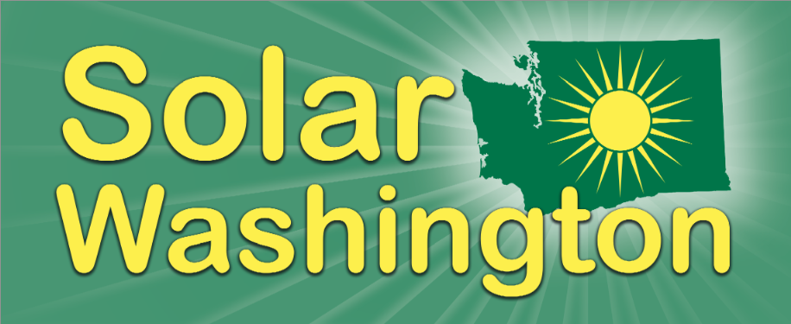 Sponsorship/Membership Form

Solar Washington is a 501(c)3 non-profit organization. Our mission is to further the development & use of solar energy in Washington. This is accomplished through the exchange of ideas and information, with concern for the economic, environmental, and social fabric of Washington State. All levels of support receive email updates about solar activities and our email newsletter. Your membership or sponsorship supports Solar Washington’s efforts to educate all Washingtonians about the uses and benefits of solar. Complete and mail this form to the address below or join online at www.solarwa.org. Thank you!

Name __________________________________________________Title ______________________________________________

Company __________________________________________________________________________________________________

Address ___________________________________________________________________________________________________

Phone Work: _______________________________________________ Home: ________________________________________________

Email Work: _______________________________________________ Home: ________________________________________________

Web _______________________________________________________________________________________________________________

COMPANY MEMBERSHIP LEVELS*:

□ $2,000 Gigawatt Sponsorship - Businesses, non-profit organizations, and governmental entities that support Solar Washington’s mission to advance solar energy in Washington and are ready to make a premier-level investment in that mission, in exchange for our highest level of recognition and visibility among Solar Washington’s members and broader constituency.

□ $1,000 Megawatt Sponsorship - Businesses, non-profit organizations, and governmental entities that support Solar Washington’s mission to advance solar energy in Washington and are ready to increase their investment in that mission, in exchange for enhanced recognition and added visibility among Solar Washington’s members and broader constituency.

□ $500 Kilowatt Sponsorship - Businesses, non-profit organizations, and governmental entities that support Solar Washington’s mission to advance solar energy in Washington.

INDIVIDUAL MEMBERSHIP LEVELS:

□ $195 Professional - To individual professionals, both within and outside the solar industry, who wish to offer greater support for our efforts to advance solar energy in Washington State.

□ $50 Individual – For anyone who wants to support our efforts to advance solar energy in Washington State.

□ $25 Student - Open to currently enrolled students, apprentices, and other trainees and their teachers who want to support our efforts to advance solar energy in Washington State. *Requires proof of current student or teacher status with your membership renewal and pledge to volunteer.

Code of Ethics

For annual Company Sponsors or Business Members only. Please check the box after reading and agreeing to Solar Washington’s code of ethics found on our website at the following link: http://www.solarwa.org/solar_washington_member_sponsor_code_of_ethics

Please return this form along with your payment via check to: Solar Washington – 1037 NE 65th St. #82046, Seattle, WA 98115. You may also join online at www.solarwa.org. All or part of your membership/sponsorship payment may be tax deductible as a charitable contribution. Please check with your tax advisor. Thank you!

*Because Solar Washington will be featuring your business to the community who trusts us, we will require that our sponsors have a B or better rating with the BBB, in good standing with Department of L&I, meet all industry standard licensing requirements for your industry, and satisfactorily address any member complaints if they occur.

