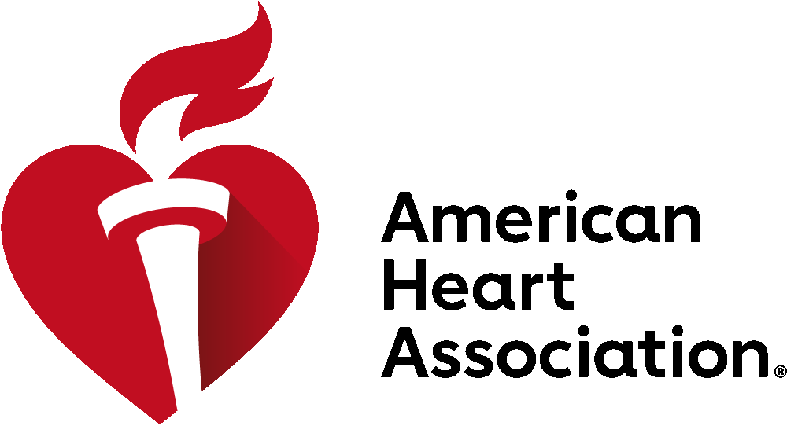

Please Support the Elimination of Youth Penalties for Tobacco

We urge Vermont legislators to remove the fines on youth for possessing and purchasing tobacco products as noted in S.41.

Youth Purchase Use or Possession (PUP) laws are not effective public health prevention, because they:
- Distract from more effective enforcement measures: Penalizing kids is not an effective strategy to reduce youth tobacco use, a finding that is even more relevant when the behavior in question is addictive. Some experts argue that PUP laws could detract from more effective enforcement measures and tobacco control efforts.

- Make kids, many of whom are addicted to tobacco, the victims. PUP laws unfairly punish and stigmatize kids, many of whom become addicted because of the tobacco industry’s aggressive marketing to kids.
- Prevent youth from seeking counseling or cessation resources for fear of being fined.

- Are not a proven measure for reducing youth smoking. Tobacco companies, including Reynolds America, and their allies have a history of supporting PUP laws as alternatives to tougher tobacco industry regulations that would produce greater declines in youth smoking.

Background
Tobacco and e-cigarette manufacturers claim they do not target youth. Yet, they sell kid-appealing, flavored tobacco products, produce colorful, tech-savvy designs and promote these products through social media. According to the U.S. Surgeon General, we now have an e-cigarette epidemic among our middle and high-school students. The statistics are alarming:

- 90 percent of adult smokers started smoking before the age of 18.
- 70% of US middle and high school tobacco users have used at least one flavored tobacco product in the past 30 days.
- There are more than 15,500 flavors on the market today. Up from 7,700 in 2014.
- Tobacco industry internet marketing increased from $125,000 in 1998 to $36.1 million in 2017
- The tobacco industry also spends billions on in-store marketing. 29% of Vermont schools are within 1,000 ft of a tobacco retailer.

PUP laws are also inequitable because they disproportionately affect youth of color:
- Youth of color are more likely to smoke because these populations have been targeted via advertising and retailer placement by the tobacco industry.
- In addition to carrying a higher burden of tobacco-related harm, African American and Hispanic youth report higher citation rates than their white peers even after accounting for smoking frequency. These findings mirror disparities recorded throughout criminal justice and school disciplinary systems.

- Enforcement of PUP laws also disproportionately affects youth from low-income communities. High smoking rates are correlated with low income, and there are more tobacco retailers and advertisements in less affluent areas. Consequently, low-income youth are more likely to smoke and to be affected by PUP laws.

- A child with a job, a single parent, or 2 parents who work outside the home may struggle to complete community service or pay fines. If a violation results in suspension of a driver’s license, travel to school, a job, or a community service site becomes more difficult. A child who is unable to complete community service or pay fines may be subject to escalating penalties that are increasingly difficult to resolve. Further, the resulting stress takes a toll on health and increases the likelihood of risky behaviors or involvement with juvenile justice, mental health, substance use, or other systems.

Public health experts know the evidence-based strategies that help reduce tobacco use and help prevent youth from ever using a tobacco product include: prohibiting the sales of all flavored tobacco products, tobacco price increases, comprehensive smoke-free policies and a fully-funded tobacco prevention program that includes strategic anti-tobacco media campaigns.

For more information, contact:
Jill Sudhoff-Guerin, jsudhoffguerin@vtmd.org, 802- 917-5817
Stephanie Winters, swinters@vtmd.org, 802-223-7898
Tina Zuk, tina.zuk@heart.org, 802-578-3466

1 Wakefield, M, and Giovino, G, “Teen penalties for tobacco possession, use, and purchase: evidence and issues,” Tobacco Control, 12(SupplI):i6-i13, 2003; Jason, LA, et al., “Youth Tobacco Sales-to-Minors and Possession-Use-Purchase Laws: A Public Health Controversy,” J Drug Education, 35(4):275-290, 2005.
U.S. Department of Health and Human Services. The Health Consequences of Smoking—50 Years of Progress: A Report of the Surgeon General. Atlanta: U.S. Department of Health and Human Services, Centers for Disease Control and Prevention, National Center for Chronic Disease Prevention and Health Promotion, Office on Smoking and Health, 2014 [accessed 2019 Feb 28].
Corey, C.G., et al., Flavored tobacco product use among middle and high school students—United States, 2014. MMWR Morbitity and Mortality Weekly Report, 2015. 64(38): p. 1066-1070
Zju, S-H, et al. Evolution of Electronic Cigarette Brands from 201302014 to 2016-2017: Analysis of Brand Websites. Journal of Medical Internet Research. 2018 Mar; 20(3) e80.
U.S. Federal Trade Commission (FTC), Cigarette Report for 2017, 2019, https://www.ftc.gov/system/files/documents/reports/federal-tradecommission-cigarette-report-2017-federal-trade-commission-smokeless-tobacco-report/ftc_cigarette_report_2017.pdf [data for top 5 manufacturers only].
https://counterbalancevt.com/get-the-facts
Bach, L. Tobacco Company Marketing to Kids. Washington, DC: Campaign for Tobacco-Free Kids. www.tobaccofreekids.org/assets/factsheets/0008.pdf . Accessed on March 5, 2019.
American Lung Association, Campaign for Tobacco-Free Kids, American Cancer Society, et al. Achieving Health Equity in Tobacco Control. truthinitiative.org/sites/default/files/Achieving%20Health%20 Equity%20in%20Tabacco%20Control%20-%20Version%201.pdf. Published December 8, 2015. Accessed on March 5, 2019.
Gottlieb NH, Loukas A, Corrao M, McAlister A, Snell C, Huang PP. Minors’ tobacco possession law violations and intentions to smoke: implications for tobacco control. Tobacco Control. 2004;13(3):237.
American Lung Association, Campaign for Tobacco-Free Kids, American Cancer Society et al. Achieving Health Equity in Tobacco Control. truthinitiative.org/sites/default/files/Achieving%20Health%20 Equity%20in%20Tabacco%20Control%20-%20Version%201.pdf.
Rew L, Horner SD. Youth resilience framework for reducing health-risk behaviors in adolescents. J Pediatr Nurs. 2003;18(6):379- 388.

